WHICH STATION ARE YOU LOOKING FOR?

- **Arshdeep Kaur, BVCOE**



How strange is it that life takes us to different places and we meet new people? This nature of life sometimes resembles a train journey. The way things happen when we travel in train, the same goes for life. We meet people, make intangible bonds and then bid adieu. The mysterious voyage of life contains the essence of the journey of a train. But there still lies a big difference, like the certain turns, halts and changing surroundings of train journey. These traits of life are much less obvious.

As we board a train, we meet new people, become friends in a few minutes and after a short while the connection appears to have reached the maximum “broadband frequency”. We chat, share emotions and have fun together. But then the train comes to a halt at a station and some of the co-passengers desert us. People who were so intimate only a few hours back, move to some other world leaving behind memories and a realization that the period of togetherness has come to its end. But then again, new passengers arrive and the cycle continues .But again we reach the same end point. Either of us has to deboard the train at a station and move on. Isn’t this what we actually experience in life?

Our childhood days and teenage, which we spend in schools and colleges, are no less than heaven. The fun, excitement and strong bonds which we share with school friends appear to be incessant. The lunch breaks, the stupid games, the class tests and the company of amazing friends in everything we do are seen as the key elements of our funny little world. But then the dynamic nature of life breaks this stability and then comes the separation. The promises of staying in touch and being the best buddies forever become so hollow. This lands us to our respective stations of college life.

The college provides a new life, new people and a place to create new memories. The goodbyes which we just said to a few are then followed by “hellos” to others. Then begins another journey, again a world of fun and frolic is created. Those whom we greeted with a formal smile initially are now the ones who compel us to burst into peals of laughter. They make us cherish every little moment of this beautiful life and stand by us through thick and thin. Therefore, by healing the older wounds of separation, they tie a thread of hope to our lives and promise to stay with us forever. And it’s the time when the smooth journey of life takes an unexpected turn and reminds us of different stations which lead to partition.

Yes!!! Even college life ceases and the pain of being without our closest friends hurts the soul.

It’s not just at different stages of our lives that the feeling of parting plays its role. It’s the law of nature which can greet us at any point of time. Sometimes it’s about very close relatives, our neighbors or someone we had not known for long but still had a strong connection emotionally.

Unlike the train journeys in which the time, place and most importantly, the destination of other passengers is known, everything is uncertain in life. In life, the emotional bonds between people don’t allow them to accept the parting phase of any relationship and therefore the unexpected goodbyes prove to be very painful. Thus the feeling of being alone knocks at the door. At this point one often asks as to why life follows such a trend? Why does it always happen that those who add life to our lives have to leave it for us to live alone? Well, the interrogations can’t be solved certainly but there does exist a hope of other stations which will bring new passengers into our lives, who would fill it with the hope to encourage us to live happily.

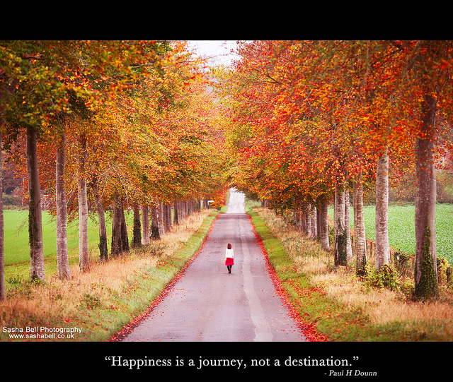



Likewise, life is also about choosing new paths. You are absolutely free to choose your own path. It’s your life, you only have to decide what’s best for you.

Your future is not determined by the school you graduate from. It’s determined by who you are as a human being. Higher education is an important tool for building character. It can be seen as climbing a high mountain. The higher you climb, the broader becomes your vision and the wider is the world that unfolds before you. You begin to see things that you could never see before. The question of where you study - whether at a school, a two-year college or a four-year university - is something that only you can decide, based on many factors, including your family circumstances, academic ability and personal desires and ambition. If you make the decision yourself, you’ll have no regrets later. You mustn’t live a life filled with indecision and lingering regret. You mustn’t feel jealous of others. There is no easy path to success.

Then, what is the purpose of our life’s journey? Obviously, to be happy. What is happiness then? It’s all about feeling contented and attaining personal satisfaction.

What is fulfillment then? It is satisfaction or happiness as a result of fully developing one's abilities or character. That can be only done when we face difficulties in our lives. Without difficulties and challenges, there can be no fulfillment, and without fulfillment, there is no happiness. There is no happiness without hardship. Everyone forgets the process of battling hardships, and searches only for the end result - the destination of happiness. Instead “happiness is a journey, not a destination”.

